**CODE REVIEW QUESTIONS**

**SENIOR WEB DEVELOPER**

1. Given an array of points where points[i] = [xi, yi] represents a point on the **X-Y** plane and an integer k, write code to return the k closest points to the origin (0, 0).

The distance between two points on the **X-Y** plane is the Euclidean distance (i.e., √(x1 - x2)2 + (y1 - y2)2). You may return the answer in **any order**.

The answer is **guaranteed** to be **unique** (except for the order that it is in).

***EXAMPLES:***

**Input:** points = [[1,3],[-2,2]], k = 1

**Output:** [[-2,2]]

**Explanation:**

The distance between (1, 3) and the origin is sqrt(10).

The distance between (-2, 2) and the origin is sqrt(8).

Since sqrt(8) < sqrt(10), (-2, 2) is closer to the origin.

We only want the closest k = 1 points from the origin, so the answer is just [[-2,2]].

**Input:** points = [[3,3],[5,-1],[-2,4]], k = 2

**Output:** [[3,3],[-2,4]]

**Explanation:** The answer [[-2,4],[3,3]] would also be accepted.

***ANSWER: (Note: Preferred language - JavaScript)***

public int[][] kClosest(int[][] points, int k) {

}

1. Give a code example to demonstrate embedding two or more components into one (Attach Code snippet).
2. Write a sample code to update the state of a component in React? (Attach code snippet).
3. Identify problems in the given code.

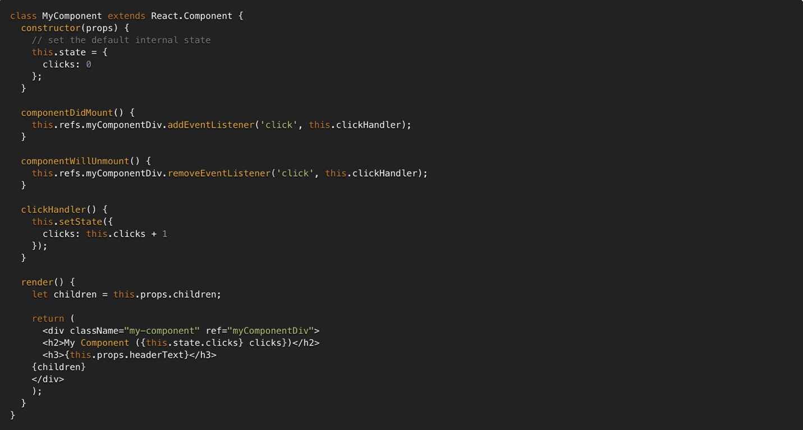

1. React hooks: What is wrong with the code?

